ROB521 Assignment 3: Stereo Vision Motion Estimation

Professor Steven Waslander – April 14, 2020  
Samuel Atkins – 1002951754

# Results:

## In-Plane Motion Plots:

This assignment required students to implement a simple point cloud alignment algorithm to help estimate the motion of a mobile robot using image data. Figures 1 and 2 delineate the mobile robot’s motion in both the x-y and x-z planes, respectively:

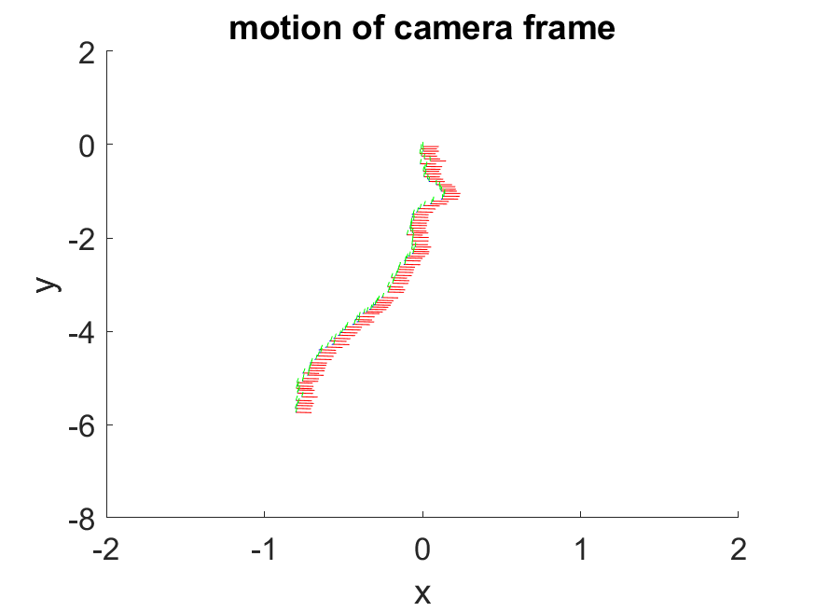

Figure 1: x-y motion of the camera frame

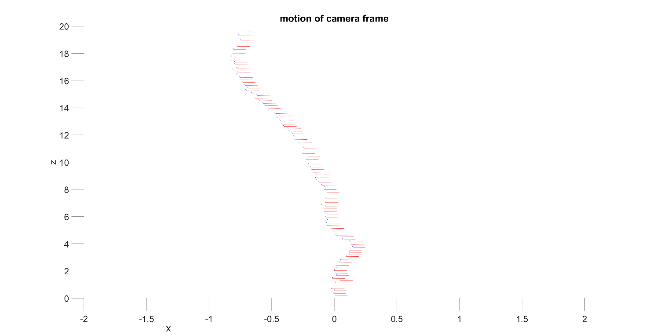

Figure 2: x-z motion of the camera frame

From these images we can see that motion of the mobile robot. These images correspond closely with the position that the robot appears to be in from the images. Furthermore, from these Figures we can see that the robot’s orientation stays stable throughout the simulation. We can also observe that there is a discontinuity in the otherwise evenly spaced orientations occurring at z = 11. This could be because of wheel slip or a sudden increase in velocity. Figures 1 and 2 above match the solution so there is no comment regarding the accuracy of the solution.

## Distance Plot:

The distance estimated using visual odometry as a function of the image index is illustrated in Figure 3 below:

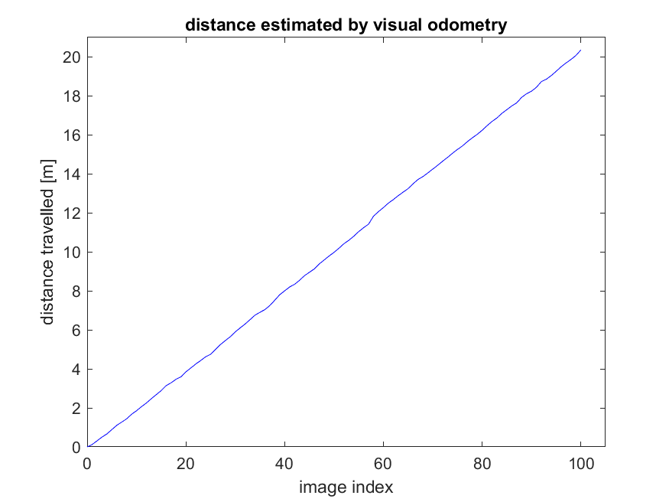

Figure : Distance estimated by visual odometry as a function of the image index

The distance increases linearly with the image index. This makes sense because from the image data and from Figures 1 and 2 we can appreciate that the mobile robot is indeed moving. Just as with Figures 1 and 2, this image matches the solution so there is no comment on the solution’s accuracy.

# Appendix: MATLAB Code

% ======

% ass3.m – Samuel Atkins (1002951754)

% ======

%

% This assignment will introduce you to the idea of estimating the motion

% of a mobile robot using stereo visual odometry. It uses a real image

% dataset gathered in the Canadian High Arctic in 2009.

%

% There is only one question to complete (10):

%

% Question: code the least-squares motion solution based on two

% pointclouds

%

% Fill in the required sections of this script with your code, run it to

% generate the requested plots, then paste the plots into a short report

% that includes a few comments about what you've observed. Append your

% version of this script to the report. Hand in the report as a PDF file.

%

% requires: basic Matlab, 'matches.mat', directory of images

%

% T D Barfoot, February 2016

%

function vo()

clear all;

% watch the included video,

matches_struct = load("import.mat");

matches = matches_struct.matches;

imax = size(matches,2);

% stereo camera parameters

b = 0.239977002; % baseline [m]

f = 387.599884033; % focal length [pixel]

cu = 253.755615234; % horiz image centre [pixel]

cv = 185.114852905; % vert image centre [pixel]

% global transform to camera (starts as identity)

T = eye(4);

% distance travelled (starts at zero)

d(1) = sqrt(T(1:3,4)'*T(1:3,4));

% initialize some figures

h1 = figure(1); clf;

h2 = figure(2); clf;

% loop over the stereo pairs

for i=1:imax

i

% get number of feature matches

npoints = size( matches{i}, 1);

% use the inverse stereo camera model to turn the first stereo pair into a pointcloud

uL1 = matches{i}(:,1);

vL1 = matches{i}(:,2);

uR1 = matches{i}(:,3);

vR1 = matches{i}(:,4);

p1 = [ b*( 0.5*(uL1 + uR1) - cu ) ./ (uL1 - uR1) ...

b*( 0.5*(vL1 + vR1) - cv ) ./ (uL1 - uR1) ...

b*f*ones(size(uL1)) ./ (uL1 - uR1) ]';

% use the inverse stereo camera model to turn the first stereo pair into a pointcloud

uL2 = matches{i}(:,5);

vL2 = matches{i}(:,6);

uR2 = matches{i}(:,7);

vR2 = matches{i}(:,8);

p2 = [ b*( 0.5*(uL2 + uR2) - cu ) ./ (uL2 - uR2) ...

b*( 0.5*(vL2 + vR2) - cv ) ./ (uL2 - uR2) ...

b*f*ones(size(uL2)) ./ (uL2 - uR2) ]';

% RANSAC

maxinliers = 0;

bestinliers = [];

p1inliers = [];

p2inliers = [];

itermax = 1000;

iter = 0;

while iter < itermax && maxinliers < 50

iter = iter + 1;

% shuffle the points into a random order

pointorder = randperm(npoints);

% use the first 3 points to propose a motion for the camera

[C,r] = compute_motion( p1(:,pointorder(1:3)), p2(:,pointorder(1:3)) );

% compute the Euclidean error on all points and threshold to

% count inliers

e = p2 - C*(p1 - r*ones(1,npoints));

reproj = sum(e.*e,1);

inliers = find(reproj < 0.01);

ninliers = size(inliers,2);

if ninliers > maxinliers

maxinliers = ninliers;

bestinliers = inliers;

p1inliers = p1(:,inliers);

p2inliers = p2(:,inliers);

end

end

% recompute the incremental motion using all the inliers from the

% best motion hypothesis

[C,r] = compute_motion(p1inliers,p2inliers);

% update global transform

T = [ C -C*r; 0 0 0 1]*T;

% update distance travelled

d(i+1) = sqrt(T(1:3,4)'*T(1:3,4));

% this figure shows the feature tracks that were identified as

% inliers (green) and outliers (red)

figure(h1)

clf;

IL1 = imread(['images/grey-rectified-left-' num2str(i,'%06i') '.pgm'], 'pgm');

imshow(IL1);

hold on;

for k=1:npoints

set(plot( [uL1(k) uL2(k)], [vL1(k) vL2(k)], 'r-' ), 'LineWidth', 2);

end

for k=1:maxinliers

set(plot( [uL1(bestinliers(k)) uL2(bestinliers(k))], [vL1(bestinliers(k)) vL2(bestinliers(k))], 'g-' ), 'LineWidth', 2);

end

% this figure plots the camera reference frame as it moves through

% the world - try rotating in 3D to see the full motion

figure(h2)

hold on;

startaxis = [0.1 0 0 0; 0 0.1 0 0; 0 0 0.1 0; 1 1 1 1];

curraxis = inv(T)*startaxis;

plot3( [curraxis(1,1) curraxis(1,4)], [curraxis(2,1) curraxis(2,4)], [curraxis(3,1) curraxis(3,4)], 'r-' );

plot3( [curraxis(1,2) curraxis(1,4)], [curraxis(2,2) curraxis(2,4)], [curraxis(3,2) curraxis(3,4)], 'g-' );

plot3( [curraxis(1,3) curraxis(1,4)], [curraxis(2,3) curraxis(2,4)], [curraxis(3,3) curraxis(3,4)], 'b-' );

axis([-2 2 -8 2 0 20])

pause(0.01);

end

% finish off this figure

figure(h2);

xlabel('x'); ylabel('y'); zlabel('z');

title('motion of camera frame');

print -dpng ass3_motion.png

% this figure simply looks at the total distance travelled vs. image

% index

figure(3);

clf;

plot(linspace(0,imax,imax+1),d,'b-')

axis([0 105 0 21])

xlabel('image index');

ylabel('distance travelled [m]');

title('distance estimated by visual odometry');

print -dpng ass3_distance.png

end

% this is the core function that computes motion from two pointclouds

function [C, r] = compute_motion( p1, p2 )

% ------insert your motion-from-two-pointclouds algorithm here------

% Checking to see if point clouds are empty:

if (size(p1, 2) == 0) || (size(p2, 2) == 0)

C = eye(3);

r = zeros(3, 1);

return

end

% Centroids:

centroid_1 = mean(p1, 2);

centroid_2 = mean(p2, 2);

p1_size = size(p1, 2);

% Computing singleton expansion:

singleton_exp_2 = bsxfun(@minus, p2, centroid_2);

singleton_exp_1 = transpose(bsxfun(@minus, p1, centroid_1));

W = singleton_exp_2* singleton_exp_1 / p1_size;

% Computing SVD:

[U, S, V] = svd(W);

C = U * [1 0 0; 0 1 0; 0 0 det(V)*det(U)] * transpose(V);

r = centroid_1 - transpose(C)*centroid_2;

% ------end of your motion-from-two-pointclouds algorithm-------

end